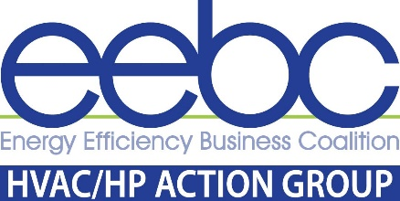
KICK-OFF MEETING DATE | October 14, 2021 | 3-4:00 pm
Mobilizing the HVAC/HP Supply Chain Together by 2030
For HP/HVAC Contractors, Distributors, Manufacturers, and Industry Stakeholders

The mission of the HVAC/HP Action Group is to work together to accelerate and transition HVAC & HP sales by taking advantage of the market development happening in Colorado to reach shared utility, cities, and
state electric and carbon-free goals by 2030
______________________________________________

AGENDA

| Welcome | Agenda - Patricia Rothwell, EEBC

| Anti-Trust Review

| Introduce “Why these meetings” - the Purpose & Opportunities

| Review Electrification Goals by 2030 | Beneficial Electrification League of Colorado [BEL-CO]
“A conversation about heat pumps” presentation to HVAC/HP Distributors and Manufacturers

| Colorado Energy Office Report May 2021 | Heat Pump Market Acceleration Project
Review 10 Top Barriers Identified in Colorado
How to Mobilize the HVAC/HP Supply Chain by 2030

| Testimonial | The Heat Pump Store - Jonathan Moscatello

| HP Action Groups
| Contractors
| Distributor and Manufacturers
| Industry Stakeholders | Utilities

| Open Forum Q&A and Discussion

